IoT Based ATV all terrain vehicle with fire sensor , gsm module and distance sensor

Interfacing and Arduino Uno R3

Rachana data (21BEE1055), Soutik mandal (21BEE1036), Aranya pal (21BEE1020)

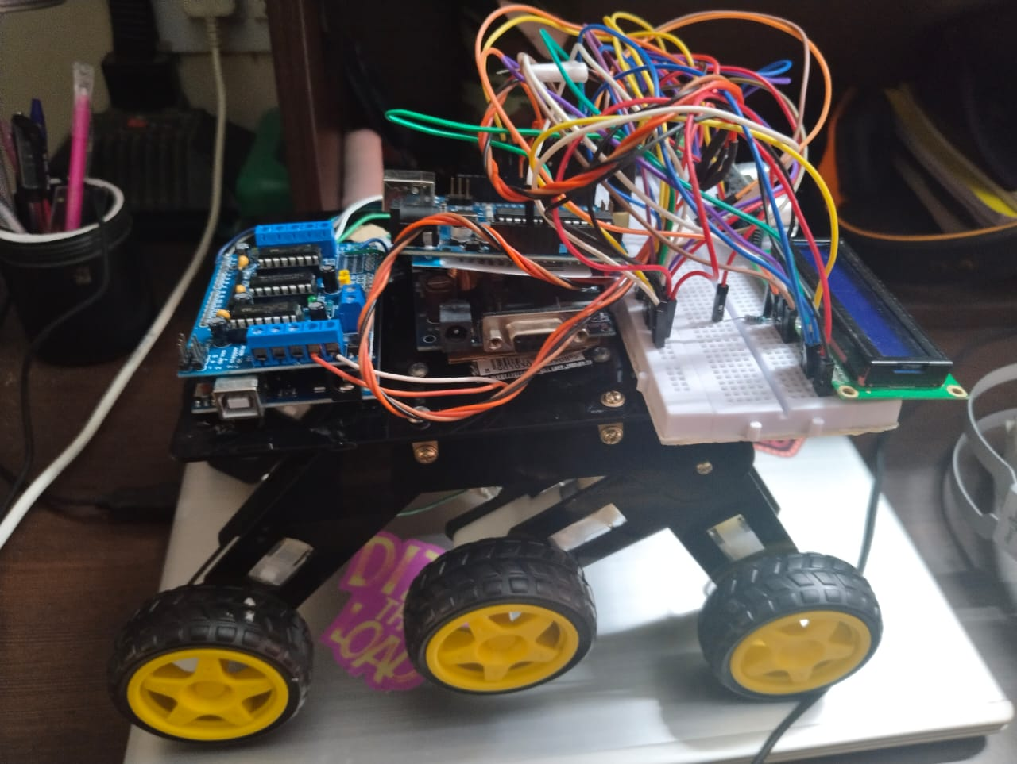

Abstract :

This project is a remote-controlled 6x6 ATV vehicle that is powered by Arduino. The vehicle is equipped with a motor driver, Bluetooth module, fire sensor, GSM module, distance sensor, and LCD. The motor driver is used to control the speed and direction of the vehicle's six motors. The Bluetooth module allows the vehicle to be controlled remotely using a smartphone or tablet. The fire sensor detects fires and sends an alert to the user's smartphone or tablet. The GSM module allows the user to track the vehicle's location and send commands to the vehicle. The distance sensor detects obstacles in front of the vehicle and prevents the vehicle from colliding with them. The LCD displays information about the vehicle's speed, direction, and battery level.

The vehicle is designed to be used for a variety of applications, including:

* Off-road racing
* Military applications
* Search and rescue
* Delivery

The vehicle is still under development, but it has the potential to be a valuable tool for a variety of applications.

Here are some additional details about the project:

* The vehicle is made of aluminum and plastic.
* The motors are powered by 12V batteries.
* The Bluetooth module uses the HC-05 chip.
* The fire sensor uses the MQ-2 sensor.
* The GSM module uses the SIM800L module.
* The distance sensor uses the HC-SR04 sensor.
* The LCD is a 16x2 LCD display.

This paper presents the design and implementation of an ATV vehicle 6x6 Arduino, motor driver, Bluetooth module, and fire sensor and GSM module. The vehicle is equipped with six motors, each of which is controlled by an Arduino Uno. The Arduinos are connected to a Bluetooth module, which allows the user to control the vehicle remotely. The vehicle also has a fire sensor, which will send an alert to the user's phone if it detects a fire. Additionally, the vehicle has a GSM module, which allows the user to track the vehicle's location.

The vehicle was designed to be easy to use and to provide a safe and enjoyable driving experience. The Bluetooth module allows the user to control the vehicle from a distance, which is helpful for parking or maneuvering in tight spaces. The fire sensor provides an added layer of safety, as it will alert the user to a fire before it becomes too dangerous. The GSM module allows the user to track the vehicle's location, which is helpful if the vehicle is ever lost or stolen.

The vehicle was successfully implemented and tested. It was able to drive safely and efficiently, and the Bluetooth, fire sensor, and GSM modules all worked as expected. The vehicle is a valuable tool for those who need a safe and easy-to-use ATV.

Here are some of the benefits of the ATV vehicle 6x6 Arduino, motor driver, Bluetooth module, and fire sensor and GSM module:

* Easy to use
* Safe and enjoyable driving experience
* Remote control via Bluetooth
* Fire sensor alerts user to potential danger
* GSM module allows tracking of vehicle's location
  1. INTRODUCTION

This ATV vehicle is a 6x6 off-road vehicle that is powered by an Arduino microcontroller. It uses a motor driver to control the six motors, a Bluetooth module to allow for remote control, a fire sensor to detect fires, and a GSM module to send text messages in case of an emergency.

The Arduino microcontroller is the brains of the vehicle. It controls the motor driver, the Bluetooth module, the fire sensor, and the GSM module. The motor driver is responsible for controlling the speed and direction of the motors. The Bluetooth module allows for remote control of the vehicle using a smartphone or tablet. The fire sensor detects fires and sends a signal to the Arduino microcontroller. The GSM module sends text messages in case of an emergency.

This ATV vehicle is a versatile and powerful vehicle that can be used for a variety of purposes, including off-road racing, camping, and exploring. It is also a great way to learn about Arduino programming and electronics.

Here are some of the benefits of using an Arduino microcontroller to control this ATV vehicle:

* Arduino is a versatile and easy-to-use microcontroller platform.
* Arduino has a large online community of users and developers.
* There are many Arduino libraries available that can be used to simplify the development of this ATV vehicle.

Here are some of the challenges of using an Arduino microcontroller to control this ATV vehicle:

* Arduino is not as powerful as some other microcontroller platforms.
* Arduino can be difficult to program for some users.
* There are not as many Arduino libraries available for off-road vehicles as there are for other applications.
* Robots are always a fancy topic for students, hobbyists and DIYers. If you are beginner, then
* building a robot (like a car or an arm) is probably one of the important projects to do after learning about the
* basics. #If you remember the earlier tutorial, I have discussed about HC-05 Bluetooth Module and how to
* interface one with Arduino. Also, I have provided a simple Bluetooth Controller App, which can be installed
* on your Android Phone and start transmitting the data. As a continuation to that project, I will be
* implementing Bluetooth Controlled Robot using Arduino and a few other components and build a simple
* robotic car that can be controlled using an Android Phone (through an App) over Bluetooth Communication.
* The robotic car can be controlled wirelessly via a Smartphone. The smartphone has an Android app through
* which the user can send commands directly to Robot. The robot can move forward, backward, left, and right
* and can also be stopped.
* The Arduino’s Bluetooth-controlled robot car is interfaced with a Bluetooth module HC-05 or HC-06. We can
* give specific voice commands to the robot through an Android app installed on the phone. At the receiving
* side, a Bluetooth transceiver module receives the commands and forwards them to the Arduino, and thus
* Robots are always a fancy topic for students, hobbyists and DIYers. If you are beginner, then
* building a robot (like a car or an arm) is probably one of the important projects to do after learning about the
* basics. #If you remember the earlier tutorial, I have discussed about HC-05 Bluetooth Module and how to
* interface one with Arduino. Also, I have provided a simple Bluetooth Controller App, which can be installed
* on your Android Phone and start transmitting the data. As a continuation to that project, I will be
* implementing Bluetooth Controlled Robot using Arduino and a few other components and build a simple
* robotic car that can be controlled using an Android Phone (through an App) over Bluetooth Communication.
* The robotic car can be controlled wirelessly via a Smartphone. The smartphone has an Android app through
* which the user can send commands directly to Robot. The robot can move forward, backward, left, and right
* and can also be stopped.
* The Arduino’s Bluetooth-controlled robot car is interfaced with a Bluetooth module HC-05 or HC-06. We can
* give specific voice commands to the robot through an Android app installed on the phone. At the receiving
* side, a Bluetooth transceiver module receives the commands and forwards them to the Arduino, and thus

The 6x6 Arduino control car with motor driver L293D and HC05 module offers several advantages for robotic enthusiasts and hobbyists. Here are some benefits of using this setup:

Versatility: The 6x6 Arduino control car can traverse various terrains due to its six-wheel drive system, making it suitable for off-road applications. It can handle uneven surfaces, inclines, and obstacles more effectively than standard four-wheel-drive configurations.

Precise Motor Control: The L293D motor driver integrated into the control car allows for precise control of the motors. It can handle the current requirements of the motors and provide speed and direction control, enabling smooth movements and accurate maneuvering.

Wireless Communication: The HC05 module provides wireless communication capabilities through Bluetooth. This allows you to control the car remotely using a smartphone, tablet, or any other Bluetooth-enabled device. Wireless control provides convenience and flexibility, especially for applications where physical connections are impractical.

Expandability: The Arduino platform offers extensive libraries and a large community, allowing you to easily expand the capabilities of the control car. You can add sensors, such as ultrasonic or infrared sensors, to enable obstacle avoidance or implement autonomous navigation algorithms to make the car more intelligent.

Learning and Educational Tool: The 6x6 Arduino control car with motor driver L293D and HC05 module is an excellent educational tool for learning robotics and programming. It provides hands-on experience in assembling, wiring, and programming a robot, helping users gain knowledge in electronics, motor control, wireless communication, and Arduino programming.

Prototyping Platform: This control car serves as a prototyping platform for experimenting with various robotics applications. You can use it as a base to build and test different robotic systems, such as robotic arms or environmental monitoring robots, by leveraging the versatility and expandability of the Arduino platform.

Cost-Effective Solution: Compared to ready-made commercial robotic platforms, building your own control car using Arduino components can be a cost-effective solution. It allows you to customize the design and functionalities based on your specific requirements, while keeping the overall costs relatively low.

Overall, the 6x6 Arduino control car with motor driver L293D and HC05 module provides a flexible, customizable, and affordable platform for robotics enthusiasts, hobbyists, and educational purposes. Its versatility, precise motor control, wireless communication, expandability, and learning opportunities make it an excellent choice for various applications and skill levels.

* 1. CIRCUIT DESIGN

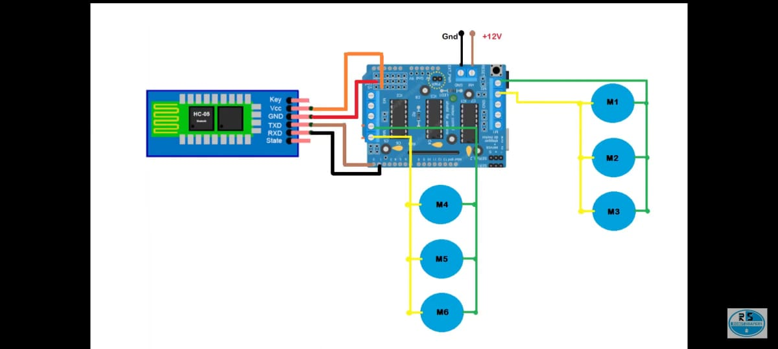

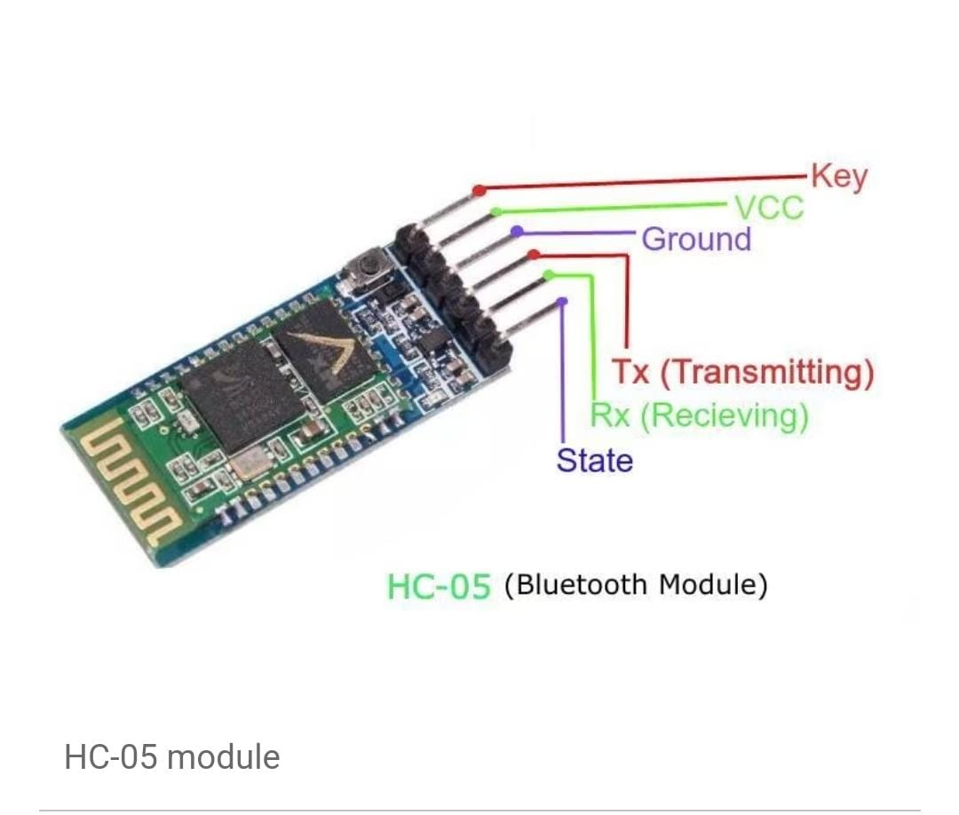

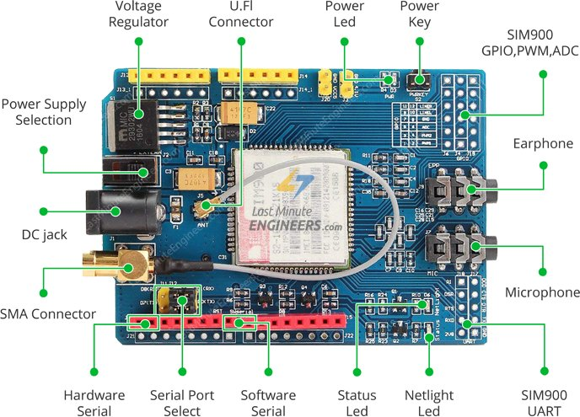

This research paper presents a smart all terrain vehicle

that utilizes various components including a 6x6 wheels,

,motors, Arduino Uno R3,motor driver,ultrasonic sensor,

red and green LEDs, a 100 Ω resistor, an LCD 16 x

2 display, a 250 kΩ potentiometer,bread board,jumper

wires,12v adapter dc,gsm module,fire sensor and a 0.2 kΩ

resistor..The red and green LEDs provide visual feedback, and

the LCD display enhances user interaction. The

resistors and potentiometer are utilized for electrical

control and regulation within the system.

* 1. HARDWARE IMPLEMENTATION

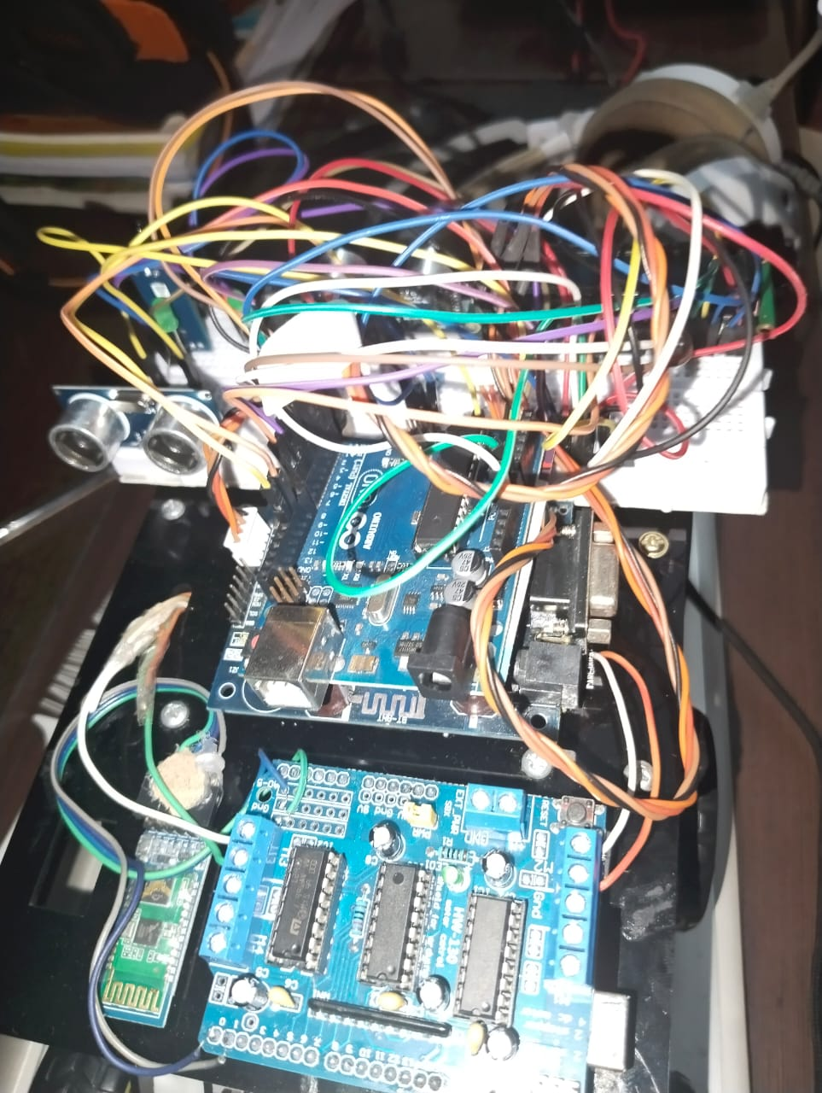

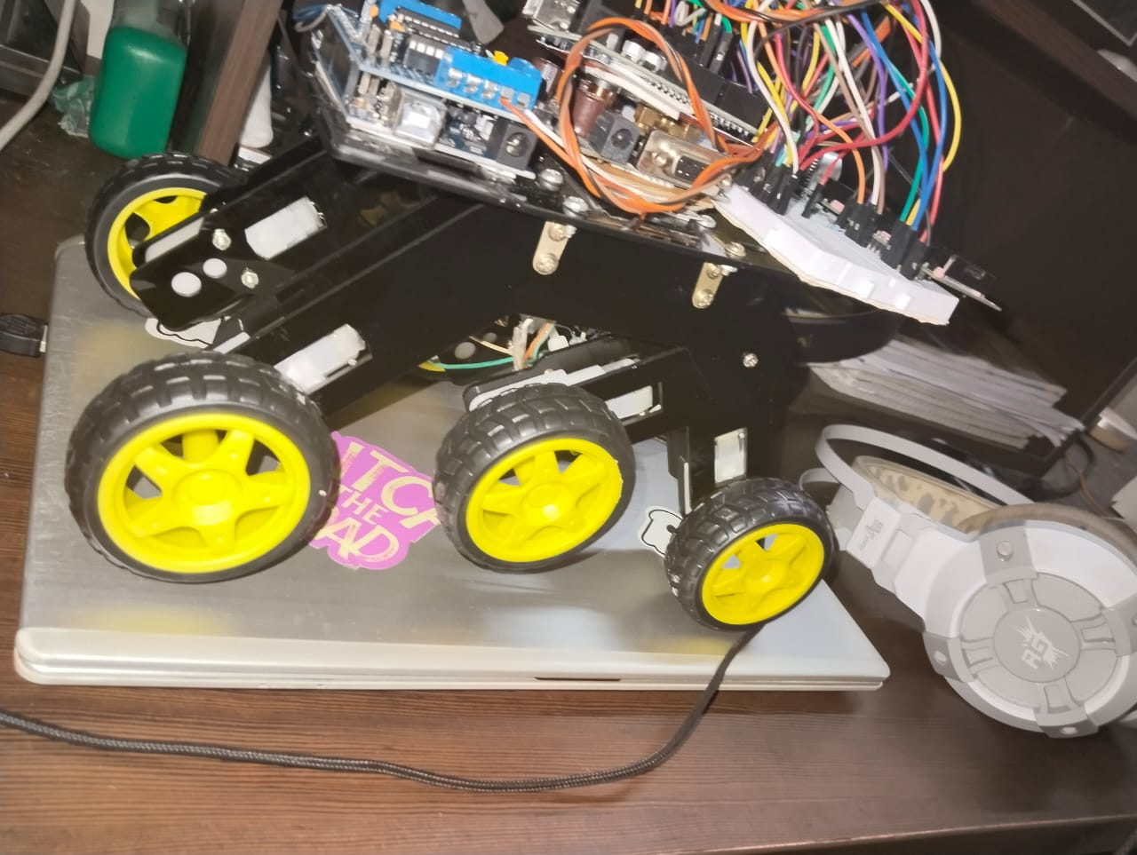

Distance sensor

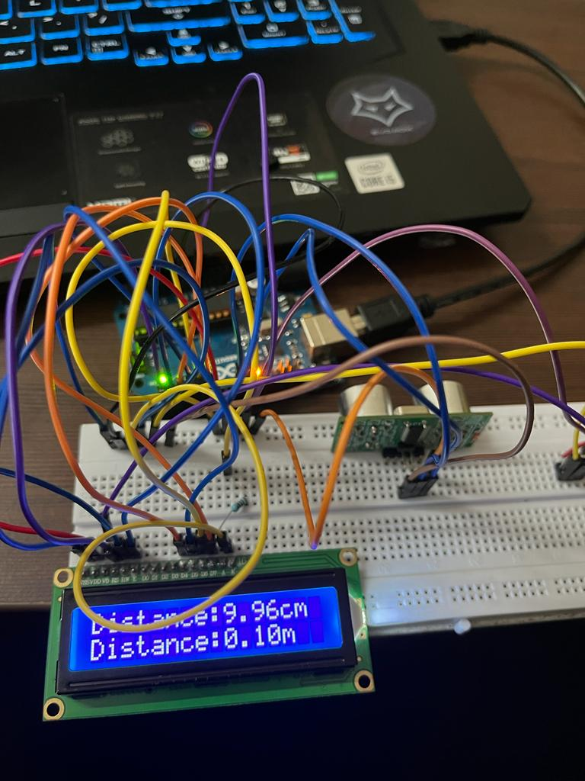

Fire sensor

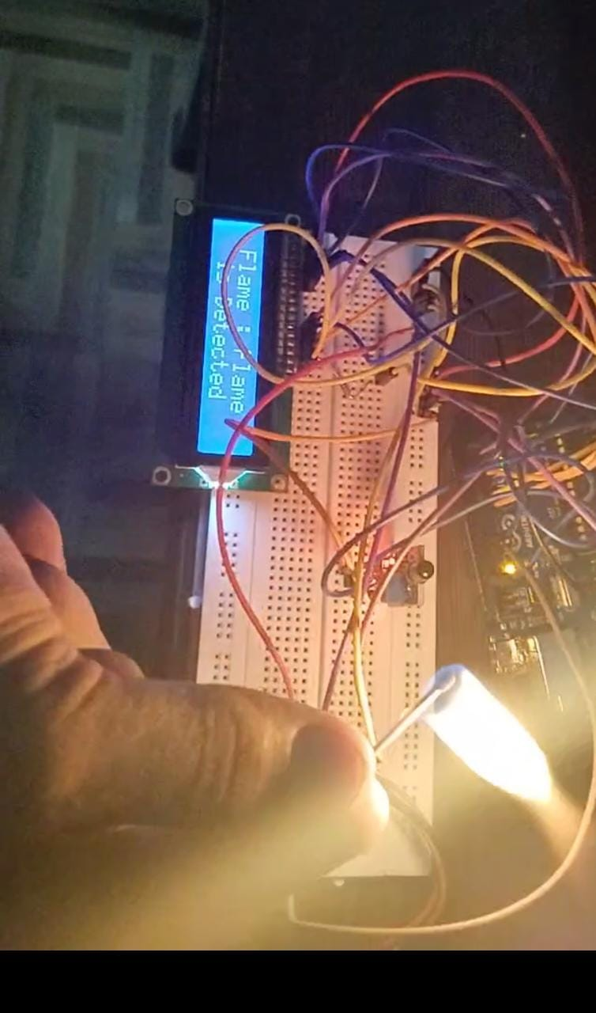

All these sensors were connected to arduino together and gsm module was connected to the tx and rx pin of the arduino and all the sensors are connected together.

Initialization:

Arduino Uno: The Arduino Uno is a microcontroller board that acts as the brain of the car. It controls various functions and communicates with other modules.

L293D Motor Driver: The L293D motor driver is used to control the motors of the car. It can handle up to two motors and provides bidirectional control (forward and reverse) for each motor.

HC-05 Bluetooth Module: The HC-05 Bluetooth module enables wireless communication between the car and a smartphone or another Bluetooth-enabled device.

Steps to create the 6×6 car:

Assemble the physical structure of the car: Build the chassis of the car using suitable materials, and attach six motors to it. Connect wheels to the motor shafts to enable movement.

Connect the motors to the L293D motor driver: Connect the six motors to the appropriate pins of the L293D motor driver. The motor driver provides separate control pins for each motor to control their direction and speed.

Connect the L293D motor driver to the Arduino Uno: Connect the control pins of the L293D motor driver to the digital output pins of the Arduino Uno. You will need at least 12 digital pins for controlling the six motors.

Connect the HC-05 Bluetooth module to the Arduino Uno: Connect the HC-05 Bluetooth module to the Arduino Uno using the hardware serial ports. Connect the TX (transmit) pin of the HC-05 module to the RX pin of the Arduino, and the RX (receive) pin of the HC-05 to the TX pin of the Arduino. Also, connect the VCC and GND pins of the HC-05 module to the appropriate power and ground pins of the Arduino.

Upload the Arduino code: Write the Arduino code to control the car's movement based on the input received from the Bluetooth module. The code should include functions to interpret Bluetooth commands and translate them into appropriate motor control signals.

Pair and connect the Bluetooth module: Pair your smartphone or other Bluetooth-enabled device with the HC-05 module. Once paired, establish a connection between the device and the module.

Control the car via Bluetooth: Use a smartphone application or terminal program to send commands to the HC-05 Bluetooth module. The module receives these commands and forwards them to the Arduino. The Arduino, based on the received commands, controls the motors through the L293D motor driver, enabling the car to move in different directions.

By following these steps, you should be able to create a 6×6 car controlled via Bluetooth using an Arduino Uno, L293D motor driver, and HC-05 Bluetooth module. Remember to handle power supply requirements, wire connections, and ensure the code is properly written to achieve the desired functionality

* 1. CODING

#include <AFMotor.h> // Library for L293D motor driver

AF_DCMotor motor1(1); // Define motors

AF_DCMotor motor2(2);

AF_DCMotor motor3(3);

AF_DCMotor motor4(4);

AF_DCMotor motor5(5);

AF_DCMotor motor6(6);

char command; // Variable to store Bluetooth commands

void setup()

{

Serial.begin(9600); // Set baud rate for Bluetooth communication

motor1.setSpeed(255); // Set motor speed (0-255)

motor2.setSpeed(255);

motor3.setSpeed(255);

motor4.setSpeed(255);

motor5.setSpeed(255);

motor6.setSpeed(255);

}

void loop()

{

if (Serial.available()) // Check if data is available from Bluetooth module

{

command = Serial.read(); // Read the incoming command

// Move forward

if (command == 'F')

{

motor1.run(FORWARD);

motor2.run(FORWARD);

motor3.run(FORWARD);

motor4.run(FORWARD);

motor5.run(FORWARD);

motor6.run(FORWARD);

}

// Move backward

else if (command == 'B')

{

motor1.run(BACKWARD);

motor2.run(BACKWARD);

motor3.run(BACKWARD);

motor4.run(BACKWARD);

motor5.run(BACKWARD);

motor6.run(BACKWARD);

}

// Turn left

else if (command == 'L')

{

motor1.run(FORWARD);

motor2.run(FORWARD);

motor3.run(FORWARD);

motor4.run(BACKWARD);

motor5.run(BACKWARD);

motor6.run(BACKWARD);

}

// Turn right

else if (command == 'R')

{

motor1.run(BACKWARD);

motor2.run(BACKWARD);

motor3.run(BACKWARD);

motor4.run(FORWARD);

motor5.run(FORWARD);

motor6.run(FORWARD);

}

// Stop

else if (command == 'S')

{

motor1.run(RELEASE);

motor2.run(RELEASE);

motor3.run(RELEASE);

motor4.run(RELEASE);

motor5.run(RELEASE);

motor6.run(RELEASE);

}

}

}

Fire Alarm using Arduino, GSM and Flame sensor */

#include <SoftwareSerial.h>

SoftwareSerial SIM900(7, 8);

String SMSTEXT;

int FlameSensor = 2;

int Buzzer = 9;

void setup() {

randomSeed(analogRead(0));

Serial.begin(9600);

SIM900.begin(9600);

Serial.println("Ready");

pinMode(FlameSensor, INPUT);

pinMode(Buzzer, OUTPUT);

digitalWrite(Buzzer, LOW);

delay(5000);

}

void loop() {

if ( digitalRead(FlameSensor) == HIGH)

{

SMSTEXT = "\nFire Detected";

analogWrite(Buzzer, 200);

sendSMS(SMSTEXT);

Serial.println(SMSTEXT);

Serial.println("Message Sent");

delay(8000);

}

if ( digitalRead(FlameSensor) == LOW)

{

Serial.println("No Fire Detected");

digitalWrite(Buzzer, LOW);

delay(1000);

}

}

void sendSMS(String message)

{

SIM900.print("AT+CMGF=1\r");

delay(1000);

SIM900.println("AT + CMGS = \"+919999999999\""); /*Add your Smart Phone Number here*/

delay(1000);

SIM900.println(message);

delay(1000);

SIM900.println((char)26);

delay(1000);

SIM900.println();

delay(100);

}

All the sensors were connected together and assembled together on top of the car



* 1. CONCLUSION

The Arduino Bluetooth module enables wireless communication, allowing the user to control the car remotely using a smartphone or other Bluetooth-enabled device. This feature provides convenience and flexibility, making it easy to operate the car from a distance.

The motor driver plays a crucial role in controlling the movement of the car. It allows precise control of the speed and direction of the car's motors, making it possible to navigate through different terrains and obstacles.

The fire sensor adds a critical safety feature to the car. It can detect the presence of fire and trigger an immediate response, such as activating an alarm or halting the car's movement. This capability helps prevent potential accidents and damage caused by fire.

The GSM module enhances the car's communication capabilities by enabling SMS alerts or notifications. This feature can be used to send important information or warnings remotely, making it easier to monitor and control the car's operations from anywhere.

Lastly, the distance sensor provides proximity detection, allowing the car to sense obstacles or objects in its path. This information can be used to implement collision avoidance mechanisms, ensuring the car can navigate safely and avoid any potential accidents.

In summary, the integration of these components in a 6x6 car powered by Arduino offers a versatile and adaptable platform. With the ability to control the car remotely, detect fire, communicate using GSM, and sense distances, it becomes a powerful tool for various applications, including exploration, surveillance, and safety monitoring.

VII. APPLICATIONS

1. Remote-Controlled Firefighting Robot: Use the fire sensor to detect flames or excessive heat. When a fire is detected, the car can be programmed to navigate towards the fire and extinguish it using a water-based system or a fire extinguisher. The Arduino can control the motors for movement, and the GSM module can send real-time updates or alerts to a designated phone number.
2. Autonomous Security Vehicle: Combine the distance sensor, motor driver, and Arduino to create an autonomous security vehicle. The car can patrol an area, detect obstacles using the distance sensor, and avoid them by adjusting its path accordingly. The GSM module can be used to send security alerts or capture images or video of suspicious activities, which can be transmitted to a remote location via Bluetooth or GSM.
3. Smart Waste Management System: Utilize the car to collect waste or recycling bins from designated locations. The distance sensor can help the car detect the bins, and the Arduino can control the motor driver for precise movement and navigation. The GSM module can be used to send notifications to a central system when the bins are full, enabling efficient waste management and collection.
4. Robotic Arm Manipulator: Install a robotic arm on the car and use the Arduino and motor driver to control its movement. The distance sensor can be used to detect objects or obstacles, allowing the arm to interact with the environment autonomously. This setup could be used in applications such as warehouse automation, object sorting, or even assistance for people with limited mobility.
5. Environmental Monitoring Vehicle: Equip the car with sensors to measure various environmental parameters like temperature, humidity, air quality, and noise levels. The Arduino can collect data from these sensors, and the GSM module can transmit the information to a central monitoring system. This setup can be used for environmental research, pollution monitoring, or smart city initiatives.